Week 1: Introduction to UI/UX Design



**Table of contents**

[1. Research and Summarize UI/UX Fundamentals 3](#_Toc4481)

[➤ What is UI Design? 3](#_Toc30424)

[Key UI Elements: 3](#_Toc18242)

[UI Design Principles: 3](#_Toc17319)

[➤ What is UX Design? 3](#_Toc30911)

[UX Design Process: 3](#_Toc16657)

[UX Principles: 3](#_Toc15865)

[➤ Key Differences: 4](#_Toc24473)

[Summary 4](#_Toc9189)

[2. Conduct User Research and Create Personas 4](#_Toc17645)

[1. Basic User Research 4](#_Toc7101)

[2. User Persona: Based on Research 5](#_Toc7811)

[3. Create Low-Fidelity Wireframes 6](#_Toc8639)

[MOBILE 6](#_Toc20949)

[WEB 9](#_Toc16098)

[MOOD BOARD 10](#_Toc16318)

[4.Explore UI Kits: 11](#_Toc25938)

[Analyzed Components: 11](#_Toc15243)

[References: 12](#_Toc26035)

**Week 1: Introduction to UI/UX Design**

# Research and Summarize UI/UX Fundamentals

## ➤ What is UI Design?

UI (User Interface) design is the visual layout of an application. It includes typography, color schemes, buttons, icons, and other graphical elements that the user interacts with.

### Key UI Elements:

* Visual Layout and Grid
* Buttons and Icons
* Typography and Color
* Input Fields
* Animations and Transitions

### UI Design Principles:

* **Consistency**: Repeating visual patterns for ease of use.
* **Clarity:** Clear and readable typography and icons.
* **Feedback:** Visual or tactile responses to user actions (e.g., a button changes color when clicked).
* **Aesthetic Appeal:** A clean and pleasing design attracts users and builds trust.

## ➤ What is UX Design?

UX (User Experience) design is the overall experience a user has while using a product. It includes usability, accessibility, user flows, and emotional response.

### UX Design Process:

* **User Research:** Surveys, interviews, competitor analysis
* **Personas:** Fictional users based on real data
* **User Flows:** Steps the user takes to complete a task
* **Wire frames & Prototypes:** Layout and interaction models
* **Usability Testing:** Test real users to find problems

### UX Principles:

* **Usability:** Is it easy to use?
* **Accessibility:** Can all users use it?
* **Information Architecture:** Is content organized logically?
* **User-Centered Design:** Focused on real needs and feedback

## ➤ Key Differences:

| **UI Design** | **UX Design** |
| --- | --- |
| Focuses on visuals | Focuses on experience |
| Involves typography, color, layout | Involves research, personas, flow |
| Done after UX planning | Done before UI design starts |
| Concerned with look | Concerned with function |

## Summary

UI and UX are **interdependent disciplines**. While UI focuses on the **presentation**, UX focuses on the **function and feeling** of the product. A beautiful interface (UI) without usability (UX) will fail, and a useful app with poor visuals may frustrate users. A successful product needs **both** strong UI and thoughtful UX working together.

# ****Conduct User Research and Create Personas****

**Hypothetical App: FocusPal**

**A mobile app that helps students improve concentration and manage study sessions.**

## Basic User Research

****Method:****

* **Conducted 5 short interviews (online chat)**
* **Surveyed 10 students using Google Forms**

****Questions Asked:****

* **What challenges do you face while studying?**
* **Do you use any productivity apps?**
* **What features would help you stay focused?**
* **What motivates you to complete study tasks?**
* **What’s your preferred device for productivity?**

****Key Findings:****

* **80% said they struggle with distractions from social media.**
* **Most students use timers but forget breaks.**
* **They want a motivating UI, progress tracking, and focus music.**
* **Prefer mobile over web due to portability.**

## User Persona: Based on Research

****USER PERSONA****

**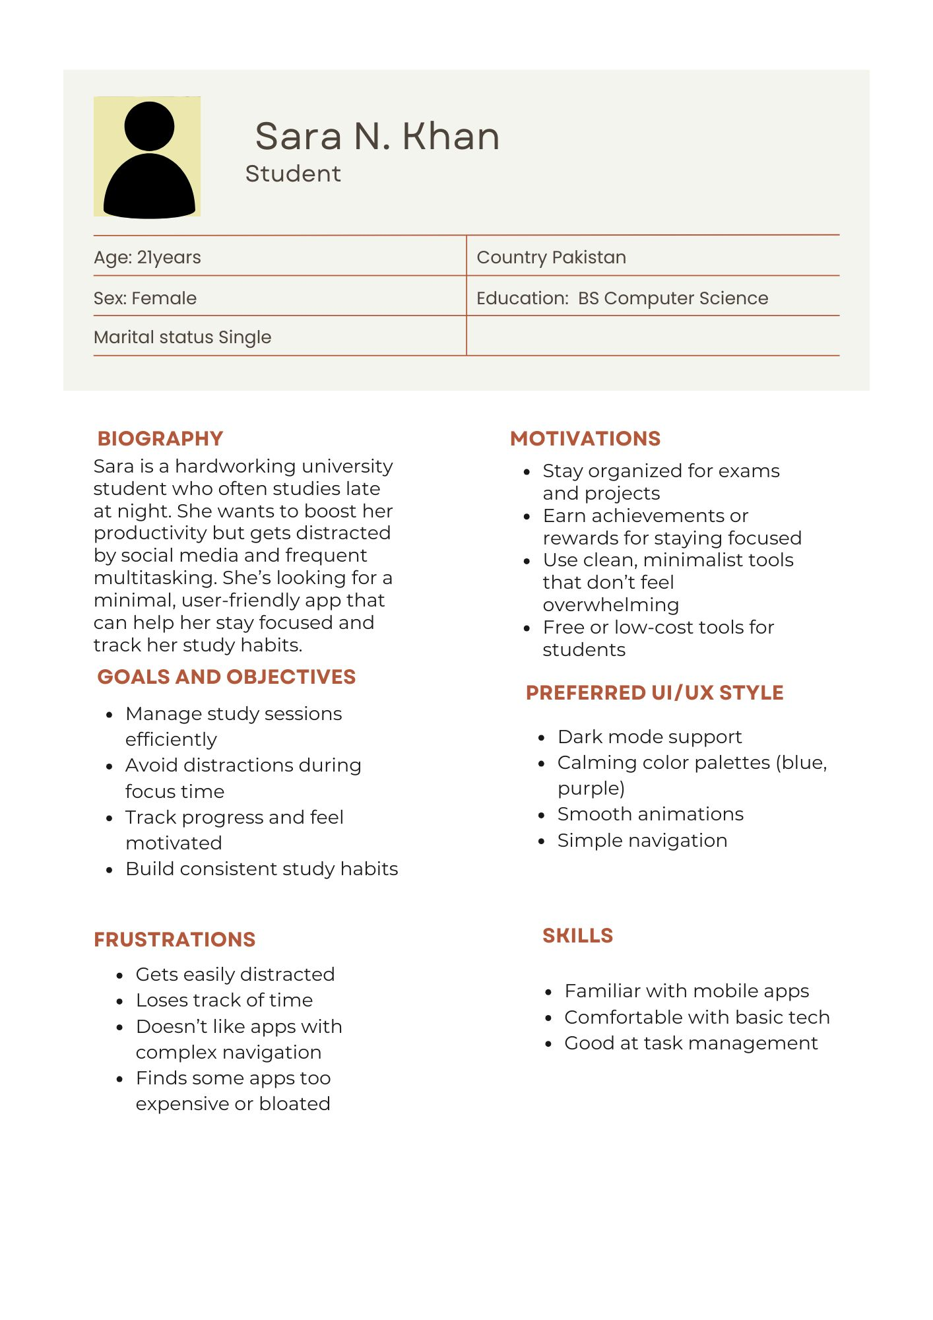**

# Create Low-Fidelity Wireframes

## MOBILE

 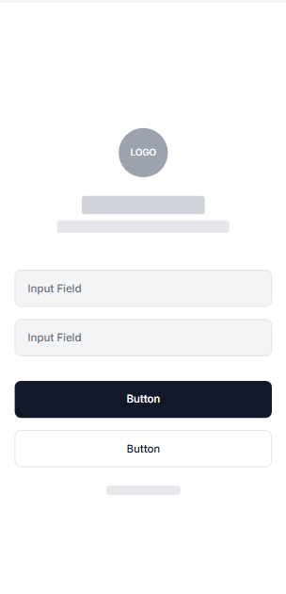

Image 1 Splash screen LOGIN/SIGNUP

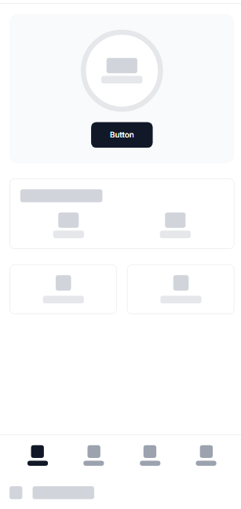 

HOME PAGE SESSION TRACKING

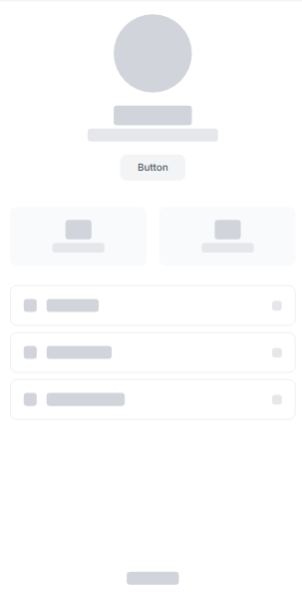

PROFILE PAGE

## WEB

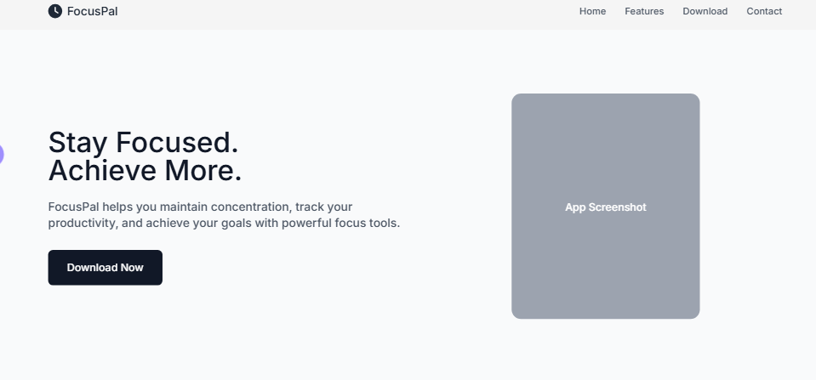

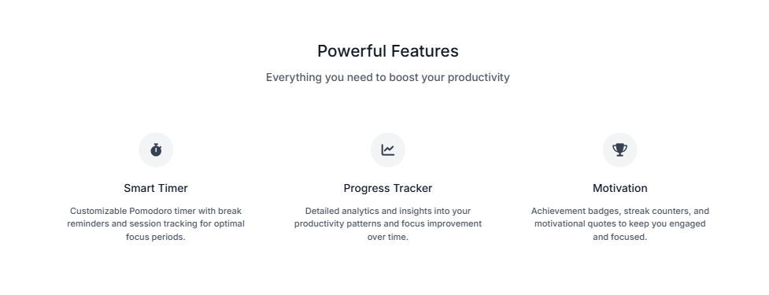

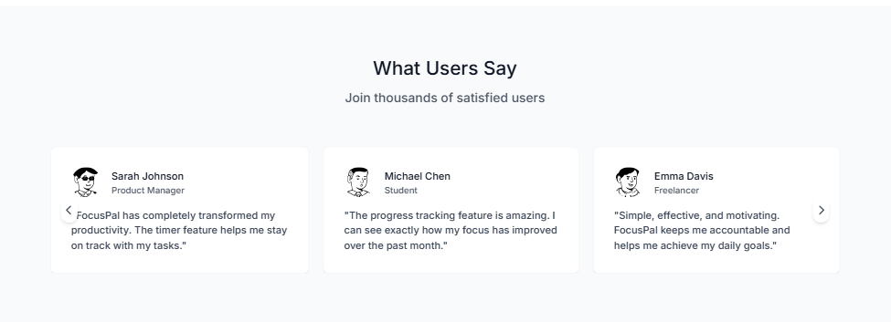

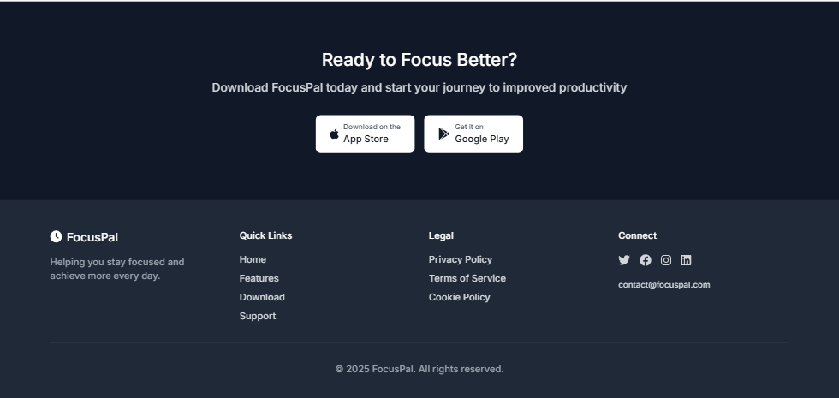

## MOOD BOARD

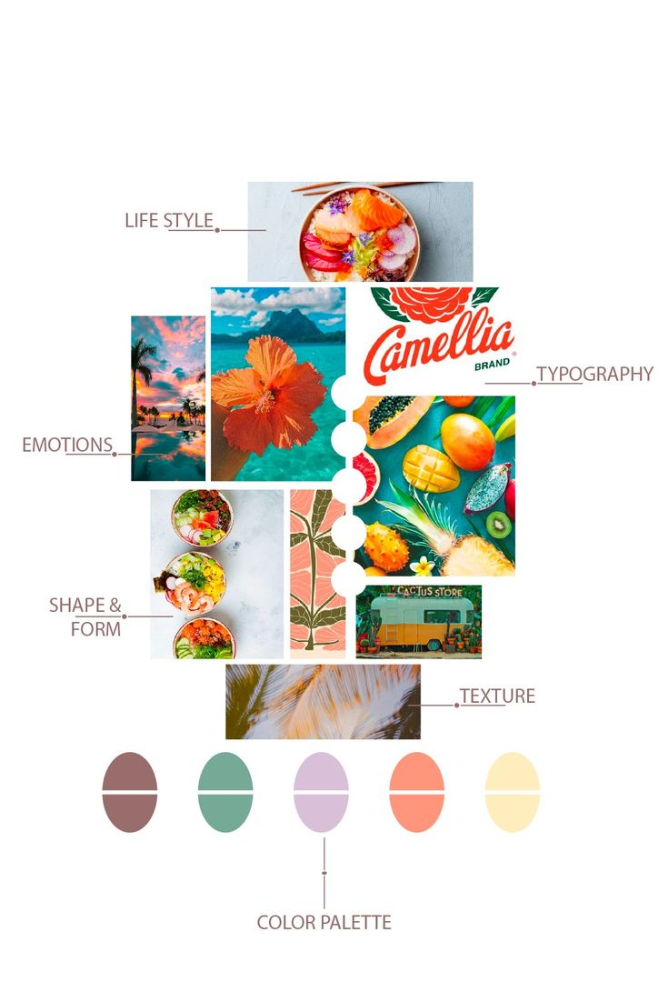

# 4.Explore UI Kits:

**UI Kit Used:** Material Design UI Kit – Figma Community

## Analyzed Components:

| **Component** | Purpose in FocusPal |
| --- | --- |
| **Buttons** | Used for primary actions like "Start Focus" and "Add Task" |
| **Cards** | To display each task or session block |
| **Navigation Bar** | Bottom nav for easy access (Home, Tracker, Profile) |
| **Input Fields** | For login, task creation |
| **Progress Bars** | Show session completion visually |

These components were reused to ensure consistency, accessibility, and faster

prototyping.

# References:

**Nielsen Norman Group**

**Interaction Design Foundation - Personas**

**[EDIT.org User Persona Template](https://edit.org/" \t "_new)**